Chapter 1 – What is an Azure Landing Zone?
Imagine This Scenario
Suppose you are constructing a new city.
Before people move into the city, what needs to be built?
- Roads, Electricity, Water Supply, Security, Traffic Rules, Police Stations, Hospitals, Government Offices
Only after all these are ready can people start building houses.
Now replace the city with Microsoft Azure.
Instead of people building houses, developers deploy:
- Virtual Machines, Storage Accounts, Databases, Kubernetes Clusters, Web Applications
If everyone starts creating resources without rules, the environment quickly becomes disorganized.
That's exactly why an Azure Landing Zone exists.

Definition:
An Azure Landing Zone is a pre-configured Azure environment that provides the foundational architecture, governance, networking, security, identity, and management capabilities required to deploy workloads safely and consistently.

Why Do We Need an Azure Landing Zone?
Imagine a company called ABC Bank.
The company has:
- 600 Developers
- 80 DevOps Engineers
- 30 Security Engineers
- 150 Applications
Without a Landing Zone, every developer can create resources however they like.
For example:
Developer A creates a VM in East US.
Developer B creates another VM in West Europe.
Developer C exposes a database to the Internet.
Developer D forgets to enable backups.
Developer E doesn't configure monitoring.
Developer F gives everyone Owner permissions.
After six months:
- Resources are spread across multiple regions.
- Security is inconsistent.
- Costs are difficult to control.
- Nobody knows who owns which resource.
- Compliance requirements are violated.
This is called cloud sprawl.

The Solution
Before allowing teams to deploy applications, the organization creates a Landing Zone.
The Landing Zone defines rules such as:
- Which Azure regions are allowed
- Naming conventions
- Networking standards
- Security policies
- Monitoring configuration
- Backup strategy
- Identity and access management
- Cost governance
Now developers simply deploy their applications while the platform automatically enforces these standards.

What Problems Does It Solve?
Without a Landing Zone:

Problem | Example
No governance | Resources created anywhere
Weak security | Public databases
Poor networking | Random virtual networks
Permission issues | Too many users have Owner access
Compliance failures | Policies are not enforced
No monitoring | No logs or alerts
High cost | Unused resources remain running

With a Landing Zone:

Feature | Benefit
Governance | Standardized deployments
Security | Secure by default
Networking | Consistent architecture
Monitoring | Centralized logging
Identity | Controlled access
Cost Management | Better resource tracking
Compliance | Policies automatically enforced

The Main Idea
An Azure Landing Zone separates responsibilities.

Platform Team | Application Team
Builds Landing Zone | Builds Applications
Configures Networking | Deploys Code
Defines Policies | Uses Existing Standards
Implements Security | Focuses on Business Logic
Manages Identity | Uses Assigned Permissions

Architect's Perspective
As an Azure Architect, your responsibility is not to deploy a single VM.
Your responsibility is to design an environment where thousands of resources can be deployed securely, consistently, and efficiently. That environment is called the Azure Landing Zone.
Key Interview Definition:

An Azure Landing Zone is a pre-configured, scalable, secure, and governed Azure environment that provides the foundational platform for deploying and managing enterprise workloads according to organizational standards and Microsoft's best practices.

Interview Questions (Chapter 1)
Q1. What is an Azure Landing Zone?
Answer:
An Azure Landing Zone is a pre-configured Azure environment that provides the foundational architecture, governance, security, networking, identity, and management capabilities required for deploying enterprise workloads in a secure and standardized manner.

Q2. Why do organizations use Azure Landing Zones?
Answer:
Organizations use Azure Landing Zones to enforce governance, improve security, standardize deployments, manage costs, ensure compliance, and provide a scalable foundation for all cloud workloads.

Q3. Is Azure Landing Zone an Azure service?
Answer:
No. Azure Landing Zone is not a single Azure service. It is an architecture and a collection of Azure services, configurations, and best practices that work together to create a secure and governed cloud environment.

CHAPTER-2

What Does an Azure Landing Zone Contain?

Core Components
An Azure Landing Zone is not a single Azure service.It is a combination of several Azure services working together.
It usually includes:

It usually includes:
- Microsoft Entra ID ( Azure Tennat)
- Management Groups
- Azure Subscriptions
- Resource Groups
- Virtual Networks
- Azure Policy
- Role-Based Access Control (RBAC)
- Azure Monitor
- Azure Firewall
- Log Analytics
- Microsoft Defender for Cloud
- Azure Key Vault
- Tags and Naming Standards

What is an Azure Tenant?

An Azure Tenant is the highest-level container in Microsoft Azure. It represents an organization's identity. It is backed by Microsoft Entra ID. A Tenant represents your organization in Microsoft Cloud. The Tenant acts as the identity boundary.

The Azure Tenant provides identity management for an organization using Microsoft Entra ID. It stores users, groups, applications, authentication settings, and Azure subscriptions.

What is an Management Groups?

A Management Group is a logical container that organizes multiple Azure subscriptions.
A Management Group is used to apply governance across multiple subscriptions.

Imagine there is one company , initially it have 1 suspcription, company grows and they have Production, developemnt, HR , Networking etc department, now susbcription increased to 100.

Question
Can the administrator configure every subscription manually?
Impossible.
This is why Microsoft introduced Management Groups.

Why Do We Need Management Groups?
Suppose client security team says "No one should create resources outside Central India."
Without Management Groups,the administrator must configure
100 subscriptions individually.Imagine tomorrow there are
500 subscriptions, its almost impossible to do or time taking job
Instead,
The administrator creates one Azure Policy.He assigns it to the Management Group.
Done. Every subscription automatically follows that policy.

Inheritance (Most Important Concept)
Settings assigned at a higher level automatically flow down to lower levels.

Governance ???
Establishing organizational rules for Azure resources.
Examples:
Only approved regions, Mandatory tags, Naming standards, Backup enabled, Monitoring enabled. Disk encryption. Allowed VM sizes. Approved SKUs. Governance ensures every deployment follows company standards.

Relationship Between Governance and Management Groups
Management Groups are the place where governance is enforced.
Governance is implemented using:
- Azure Policy
- RBAC
- Resource Locks
- Tags
- Naming Standards
All of these can be assigned at the Management Group level.

Azure Subscription ????
An Azure Subscription is a logical container for Azure resources that also acts as a billing, quota, and security boundary.

Why Multiple Subscriptions?
Imagine XYZ company has:
- Production
- Development
- Testing
- Networking
- Security
Question:
Why not keep everything in one subscription?
Because subscriptions provide isolation.
Billing Boundary Production spends $120,000/month / Development spends $8,000/month
Security Boundary (Developers need Contributor access in Development, But only Reader access in Production) Separate subscriptions make this simple.
Quota Boundary Azure limits many resources per subscription. i.e VM, Public IP , CPU’s
Management Boundary Different teams can independently manage their own subscriptions.

Interview Questions
Q1. What is the difference between an Azure Tenant and an Azure Subscription?
Answer:
An Azure Tenant is the identity boundary of an organization and is backed by Microsoft Entra ID. It stores users, groups, applications, and authentication settings. An Azure Subscription is a billing, quota, and management boundary where Azure resources are deployed.

Q2. Why do enterprises use Management Groups?
Answer:
Management Groups allow organizations to organize multiple subscriptions and centrally apply governance, Azure Policies, and RBAC. This ensures consistent security and compliance across all subscriptions.

Q3. What is inheritance in Azure?
Answer:
Inheritance means that configurations such as Azure Policies and RBAC assignments applied at a higher level (for example, a Management Group) automatically apply to lower levels such as Subscriptions, Resource Groups, and Resources.

Q4. Why do enterprises create multiple subscriptions?
Answer:
Multiple subscriptions provide isolation for billing, security, quotas, management, and compliance. They also help organizations separate production, development, networking, and other workloads.

Architect Interview Discussion – Chapter 2
Scenario 1
Interviewer:
Your company has only one Azure subscription today. As an Azure Architect, would you recommend creating Management Groups?
A weak answer:
"Yes, because Microsoft recommends it."
An architect-level answer:
"If the organization currently has only one subscription and doesn't expect significant growth, Management Groups may not provide immediate value. However, if the organization plans to expand to multiple subscriptions for production, development, networking, security, or different business units, introducing Management Groups early simplifies governance and avoids restructuring later."

Scenario 2
Interviewer:
Why can't we put Production and Development in the same subscription?
Billing boundary , Security boundary , Quota boundary , Management boundary
Cost reports become mixed, Developers may accidentally receive excessive permissions, Resource quotas are shared,Governance becomes more difficult, The risk of impacting production increases.

AZURE LANDING ZONE WITH GEMINI
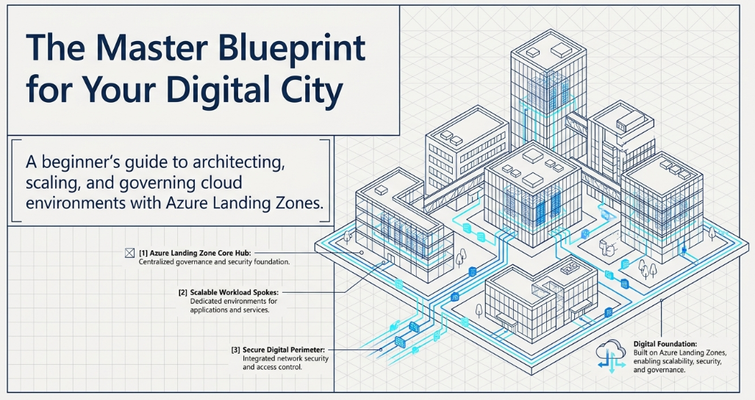
A strategic architectural framework designed to help organisations scale, secure, and govern their cloud environments effectively.

This infrastructure is composed of a platform landing zone, which provides a centralised foundation for shared services and governance, and application landing zones, where specific business workloads are hosted.

Microsoft offers accelerators to speed up deployment using pre-configured industry standards, though businesses can also create custom builds to meet unique requirements. By establishing a clear management group hierarchy,

WHY LANDING ZONE REQUIRED?

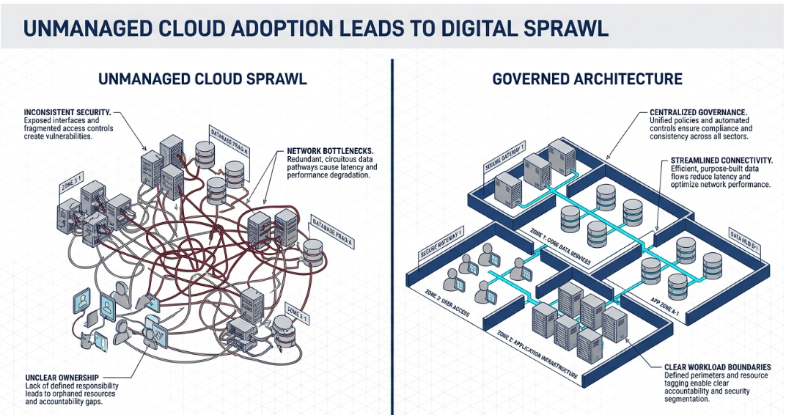

Platform Landing Zone :- Its primary purpose is to establish governance, security, and shared resources that apply to all workloads

Key characteristics include:
Management Group Hierarchy: It provides a structure to organize subscriptions and consistently apply governance standards without excessive administrative complexity.

Shared Capabilities: It centrally hosts services that provide economic or operational benefits when shared, such as networking/connectivity, identity services (Active Directory), and security monitoring

Distribution: A critical function of the platform is to provide a repeatable process for creating and distributing application landing zones to various teams.

Scale: Most organizations typically require only one platform landing zone per Microsoft Entra tenant

Application Landing Zone : An application landing zone (also called a workload landing zone) is the specific environment where workload teams deploy and operate their resources.

Workload-Specific: Each workload has a single application landing zone that contains all necessary environments, including development, testing, and production

Policy Inheritance: These zones are placed within the management group hierarchy (e.g., under "Corp" or "Online" groups), allowing them to automatically inherit governance and security guardrails defined in the platform landing zone

Operational Autonomy: While staying within the platform's guardrails, workload teams own and operate the resources within their specific landing zone

Key Differences Between Platform and Application Landing Zones

Feature | Platform Landing Zone | Application Landing Zone
Purpose | Establishes the centralized foundation for governance, security, and shared resources. | Provides the execution environment for specific workloads, including dev, test, and production.
Quantity | Typically one per Microsoft Entra tenant. | One per workload; an organization may have many.
Ownership | Managed by a central platform team responsible for the overall Azure estate. | Operated by workload teams who own the resources, code, and data for their specific business outcome.
Resources | Centralized services like connectivity (hub), identity, and security monitoring. | Workload-specific resources like virtual machines, databases, AI models, and app services.
Governance | Defines and implements the policies and management group hierarchy. | Inherits the governance and security guardrails from the platform hierarchy.

Why They are Required Separately
The separation of these zones is a core design principle aimed at achieving the following organizational benefits

1. Subscription Democratization and Speed
Separating the two allows for subscription democratization, which accelerates application development. By providing application teams with their own zones, they can manage resources independently within the platform’s guardrails. This removes the bottleneck of a central team having to manually approve every resource change, allowing workload teams to deliver value faster
* Democratisation (or democratization) is the process of making a country, government, or group use democratic ways.

2. Policy-Driven Governance at Scale

The platform landing zone uses Azure Policy to create "guardrails". When application zones are created and placed within the management group hierarchy, they automatically inherit these controls. This ensures that as an organization grows from 10 to 100 workloads, every environment remains compliant with security and regulatory standards without manual intervention

3. Separation of Concerns and Risk Reduction

Using separate zones (and subscriptions) creates a clear boundary for organizing and managing resources.
- Operational Integrity: Changes to a specific application do not inadvertently impact the shared networking or identity services of the platform.
- Security: If one application environment is compromised, the impact is contained within that specific landing zone rather than affecting the entire enterprise foundation

4. Avoiding "Shadow IT" (Cloud Sprawl)

Cloud Sprawl us situation ko kehte hain jab ek organization ka cloud environment uncontrolled aur ungoverned tarike se failne lagta hai

1. Cloud Sprawl ke Karan Complex Processes, Shadow IT, Automation ki Kami

Shadow IT Teams aksar apne alternative billing accounts ka use karke ya non-managed Microsoft Entra tenants mein subscriptions bana leti hain, jo organization ke central control se bahar hote hain

2. Iske (Impact) Security aur Compliance Risks, Operational Overhead, Integration Complexity

3. Azure Landing Zone ise kaise rokta hai?

Subscription Democratization: Ye workload teams ko azadi deta hai ki wo apne resources
khud manage karein, lekin platform ke governance guardrails ke andar reh kar
Automated Subscription Vending: Ek fast aur repeatable process ke zariye subscriptions di jati hain, taaki teams ko Shadow IT ka sahara na lena pade

Policy-Driven Governance: Azure Policy ka upyog karke ye pakka kiya jata hai ki har naya environment automatically organization ke standards ko follow kare

Technology adoption in an Azure landing zone --->

An Azure landing zone supports new and emerging technologies without requiring changes to the overall architecture. You deploy workload resources into application landing zones regardless of workload type, such as AI. As new requirements emerge, you update the governance and security policies in the platform landing zone. Those policies are then applied consistently across application landing zones, which helps you adopt new technologies faster and maintain consistency across all workloads of that type

Azure landing zone design principles ?

- Subscription Democratisation
Subscription democratization provides a scalable way to accelerate application migrations and new application development. This approach enables workload teams to access and manage Azure subscriptions independently, while staying within platform governance and operational guardrails.

- Policy-Driven Governance
Use Azure Policy to provide guardrails and ensure that the applications you deploy comply with your organization's security, governance, and regulatory control

Impact of deviation
Increased operational and management overhead. If you don't use Azure Policy to create guardrails within your environment, you increase the operational and management overhead of maintaining compliance. Azure Policy helps you restrict and automate your desired compliance state within your environment.

3. Single Control and Management Plane
4. Application-Centric Service Model
5. Alignment with Azure-Native Design and Roadmaps

Azure landing zone design areas and conceptual architecture

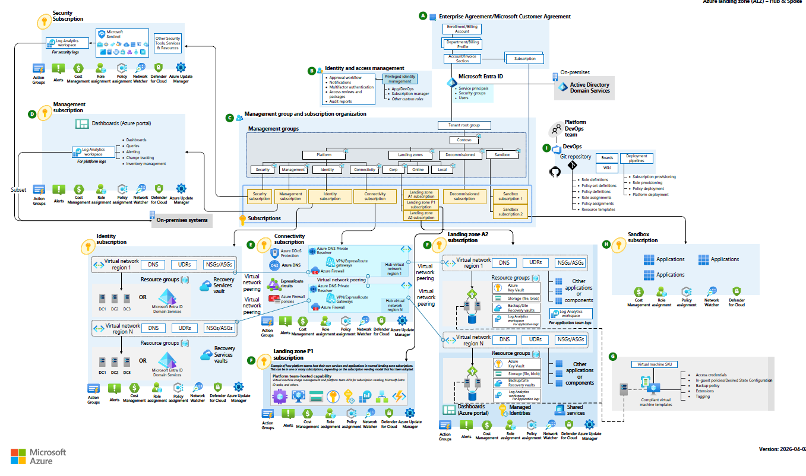

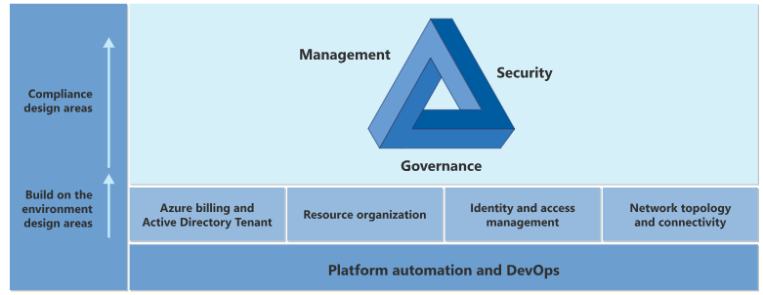

Environment design areas

Legend | Design area | Objective
 | Azure billing and Active Directory tenant | Proper tenant creation, enrollment, and billing setup are important early steps.
 | Identity and access management | Identity and access management is a primary security boundary in the public cloud. It's the foundation for any secure and fully compliant architecture.
 | Resource organization | As cloud adoption scales, considerations for subscription design and management group hierarchy have an impact on governance, operations management, and adoption patterns.
 | Network topology and connectivity | Networking and connectivity decisions are an equally important foundational aspect of any cloud architecture.

Legend | Design area | Objective
 | Security | Implement controls and processes to protect your cloud environments.
 | Management | For stable, ongoing operations in the cloud, a management baseline is required to provide visibility, operations compliance, and protect and recover capabilities.
 | Governance | Automate auditing and enforcement of governance policies.
 | Platform automation and DevOps | Align the best tools and templates to deploy your landing zones and supporting resources.

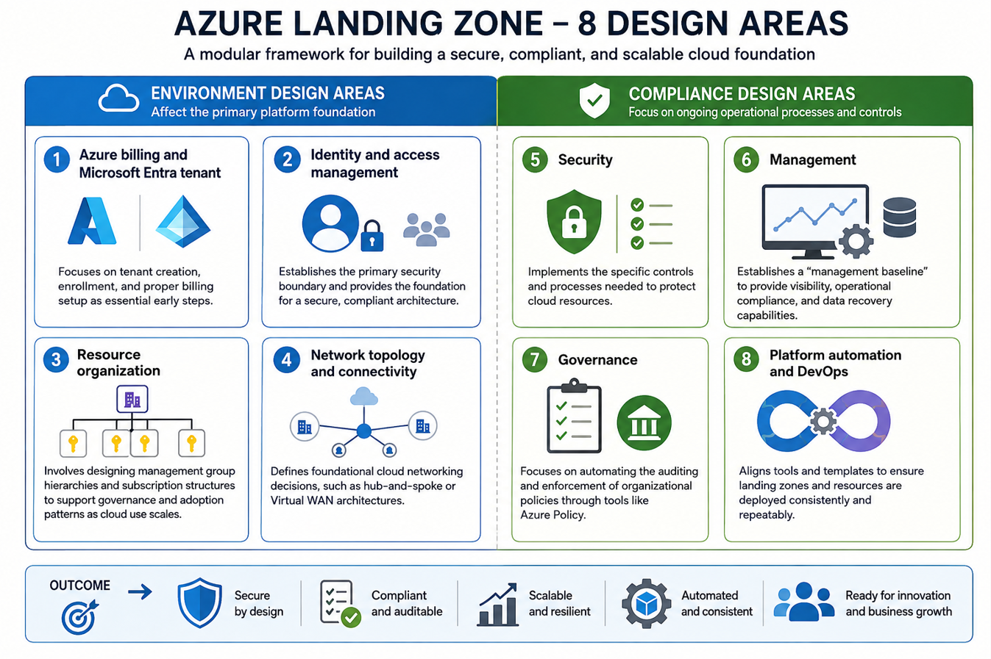

Azure billing offers and Microsoft Entra tenants

Scope: The objective of this exercise is to evaluate the various offer types and Microsoft Entra tenant association is best suited for your overall environment.
Out of scope: This design area doesn't focus on the identity or management aspects of Microsoft Entra ID, only the tenant in which your identities will ultimately be hosted.

The Azure service presents a range of active subscription offers, and customers can use these offers at the same time to gain flexible billing options. Example subscriptions include Enterprise Agreement (Enterprise Agreement), Microsoft customer agreement, cloud service provider, and others.

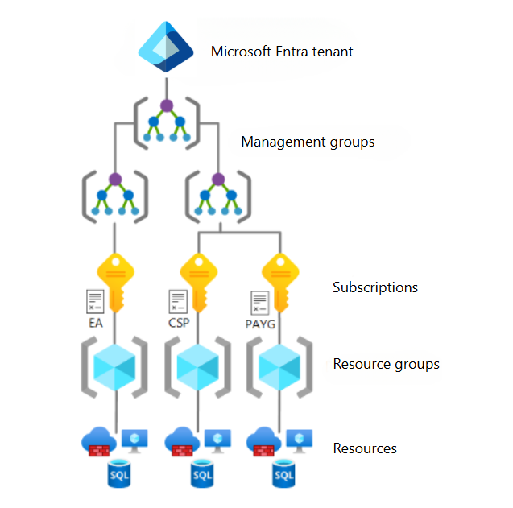

The Azure landing zone architecture supports subscriptions from any Azure offer. Subscriptions can only exist within one Microsoft Entra tenant to then relocate into the management group hierarchy within that tenant.

- Azure billing offers

Model | Simple meaning | Who manages billing? | Typical use
EA – Enterprise Agreement | Large enterprise contract with Microsoft | Organization | Large enterprises
MCA – Microsoft Customer Agreement | Modern, flexible Microsoft agreement | Organization | Modern Azure purchasing
CSP – Cloud Solution Provider | Azure purchased through a Microsoft partner | CSP partner | Organizations wanting partner-managed services

- Define a Microsoft Entra tenant
A simple hierarchy to remember:
Microsoft Entra Tenant
↓
Management Groups
↓
Subscriptions
↓
Resource Groups
↓
Resources

An Azure subscription can trust only one Entra tenant at a time, although one tenant can be associated with many subscriptions. Multiple tenants can exist in the same EA/MCA arrangement, but Microsoft recommends avoiding multiple tenants unless there is a genuine business requirement because they increase management complexity and security risk.

What should you design?
For an enterprise Landing Zone, decide:
Identity
- Do we already have Entra ID?
- Are we synchronizing on-premises AD?
- What is our SSO strategy?
- How will users authenticate?
Security
- MFA
- Conditional Access
- Privileged Identity Management (PIM)
Operations
- Central Entra diagnostic logs
- Azure Monitor / Log Analytics
- RBAC
- Service principals / managed identities
Multi-tenant
- Do we actually need multiple Entra tenants?
- If yes, why?
- How will cross-tenant access work?
- Can Azure Lighthouse be used for delegated access?

Multiple Microsoft Entra tenants are not the recommended in what cases it required give an example

When you create a new Microsoft Entra tenant, it requires extra work to provision, manage, secure, and govern the identities. You must also establish the required policies and procedures.

Moving to a multitenant model creates a boundary, which can result in user friction, management overhead, and increase the attack surface area, which can cause a security risk and complicates product scenarios and limitations.

Example 1 — Company acquisition
Example 2 — Regulatory / legal separation
Example 3 — Completely independent business entities
Example 4 — Divestiture / Company separation

Microsoft recommends a single Entra tenant where possible because multiple tenants increase identity, security, governance and operational complexity. Multiple tenants can be justified when there is a strong business or organizational requirement, such as mergers and acquisitions, divestitures, legally independent organizations, or specific regulatory/security isolation requirements."

Company A
│
└── Entra Tenant A
├── Users
└── Azure Subscriptions

Company B
│
└── Entra Tenant B
├── Users
└── Azure Subscriptions

Tenant A ←→ Tenant B

Identity and access management design area
Identity and access management

Identity and access management (IAM) is a foundational design area for building secure and fully compliant public cloud architectures. It establishes a security perimeter in the cloud by using authentication and authorization controls to ensure that only approved requests are granted.

The core objective of IAM is to ensure the right individual can access the right resources at the right time, and for the right reason, while providing reliable audit logging and nonrepudiation of actions

This comprehensive overview of Identity and Access Management (IAM) within the Azure Landing Zone (ALZ) framework is drawn from the provided sources.

Microsoft Entra ID and Identity Architecture Microsoft Entra ID (formerly Azure AD) is the core cloud-based identity service that provides robust capabilities for managing users, groups, and access

identity infrastructure is a platform responsibility because it secures all dependent services

Authentication vs. Authorization
- Authentication verifies the identity of a user or workload (ensuring they are who they say they are) to grant an "approved request".
- Authorization uses access controls to safeguard data by determining "who can do what" once they are authenticated.

Azure RBAC: Roles, Scopes, and Inheritance
Role-Based Access Control (RBAC) manages administrative privileges to Azure resources like VMs and databases

Roles: Can be built-in (Owner, Contributor, Reader) or custom if specific granular permissions are needed
Scopes: Roles can be assigned at the tenant, management group, subscription, or resource group level
Inheritance: Permissions assigned at higher levels (like a management group) are automatically inherited by all child resources (like subscriptions and resource groups)

Access Type PIM and Just-In-Time (JIT) Privileged Access

PIM Microsoft Entra Privileged Identity Management (PIM)
is used to enforce Just-In-Time (JIT) access. This ensures that users only have privileged roles when actively required; permissions are automatically removed once the task is complete, reducing the risk of permanent "standing" access.

Conditional Access and MFA
- Multi-Factor Authentication (MFA): Essential for reducing credential theft; phishing-resistant MFA is highly recommended for all users with rights to the Azure environment.
- Conditional Access: Provides "if-then" policies (e.g., "if a user is in an untrusted location, require MFA") to control access based on risk profiles

Key Comparison: RBAC vs. Entra Roles

Feature | Microsoft Entra ID Roles | Azure RBAC Roles
Control Scope | Tenant-wide services (Teams, Exchange, Intune) | Azure resources (VMs, DBs, Subscriptions)
Example Role | Global Administrator | Virtual Machine Contributor
Management | Manage tenant-level identity settings | Manage resource data and control planes

Azure identity management and access control security best practices:

- Treat identity as the primary security perimeter.
- Centralize identity management.
- Manage connected tenants.
- Enable single sign-on.
- Turn on Conditional Access.
- Plan for routine security improvements.
- Enable password management.
- Enforce multifactor verification for users.
- Use role-based access control.
- Lower exposure of privileged accounts.
- Control locations where resources are located.
- Use Microsoft Entra ID for storage authentication.

IAM in Azure Landing Zone IAM decide karta hai ki "kaun" Azure mein hai, "woh kaun hai", aur "usse kya karne ki permission hai".

WHO are you? → Identity
Are you really you? → Authentication
What can you do? → Authorization

Suppose Azure mein ek Production VM hai.
Prince Microsoft Entra ID Authentication Azure RBAC Can Prince restart the VM?
Agar Prince ko Virtual Machine Contributor permission mili hai → VM restart kar sakta hai.
Agar sirf Reader hai → VM dekh sakta hai, modify nahi kar sakta.

1. Microsoft Entra ID Microsoft Entra ID is Azure's cloud-based identity and access management service. It manages users, groups, applications, service principals, and authentication.
2. Authentication vs Authorization
3. Microsoft Entra Roles Microsoft Entra roles control what an administrator can do inside Entra ID.

Examples:
- Global Administrator
- User Administrator
- Application Administrator
- Security Administrator
- Privileged Role Administrator

Example
Suppose HR team ko users create/delete karne hain.
User Administrator role diya ja sakta hai.
They can manage users, but that doesn't automatically mean they can manage Azure VMs.

4. Azure RBAC "What can this identity do to Azure resources?"
Reader || Contributor || Owner || Virtual Machine Contributor || Network Contributor

5. RBAC Scope RBAC permission kahaan apply hogi?
Management Group Subscription Resource Group Resource
Role assignment kisi bhi appropriate scope par diya ja sakta hai ??

Contributor Subscription “assign kiya hai, to user us subscription ke andar resources manage kar sakta hai”
Contributor RG “assign kiya hai, to permission primarily us Resource Group tak limited rahegi”

Important principle
Grant access at the lowest scope necessary.
This is Least Privilege.

6. RBAC Inheritance ???
Subscription
Agar Kisi user ko Subscription pe Reader De diya to vo RG-App mein bhi dekh sakega and RG-Network pe bhi
│
├── RG-App
│ └── VM
│
└── RG-Network
└── VNet

7. Owner vs Contributor vs Reader

Role | What it can do
Reader | View resources
Contributor | Create/modify/delete resources
Owner | Contributor + manage access/RBAC

8. PIM – Privileged Identity Management Permanent admin access ko avoid karna.

Azure production mein emergency issue hai.
Admin ko Owner access chahiye.
He activates the eligible role for 1 hour.
Kaam complete → access automatically remove.
This is called Just-In-Time (JIT) privileged access.

9. Conditional Access "Under what conditions should this user be allowed to access?"

For example:
Outside corporate network → Require MFA.
Another:
Unknown/unmanaged device → Block access.

10. MFA
MFA = Multi-Factor Authentication
Instead of only: Password you require another authentication factor.

11. Managed Identity
Ab ye workload identity hai.
Suppose Azure VM ko Key Vault se secret read karna hai. VM ko role diya Key Vault Secrets User

12. System-assigned vs User-assigned Managed Identity
System-assigned Identity Azure resource ke saath tied hoti hai.
User-assigned Identity separately create hoti hai.

13. Service Principal Service Principal ek application/workload identity hai jo applications ya automation ko Azure resources ke against authenticate karne ke liye use ki ja sakti hai.

14. Hybrid Identity Agar company ke paas already: On-Premises Active Directory hai aur woh Azure bhi use karna chahti hai, to Hybrid Identity use hoti hai. User ek corporate identity use karke on-premises aur cloud resources access kar sakta hai.
15. Microsoft Entra Domain Services Agar legacy application ko traditional protocols (like Kerberos ) chahiye to Entra Domain Services useful ho sakti hai.
16. Identity Governance "Kisko access diya hai, kyun diya hai, aur kya usse abhi bhi access chahiye?"
Examples: Access Reviews, Entitlement Management, Lifecycle Management, Privileged Access, Removing unnecessary permissions
Example : Employee leaves company : Employee leaves Identity disableAzure access removed.

19. Least Privilege User ko sirf utni permission do jitni usko kaam ke liye required hai.
20. Break-Glass Account ??? Break-glass account = emergency administrative account.
Suppose Conditional Access configuration galat ho gayi aur administrators bhi login nahi kar pa rahe.
Emergency account use kiya ja sakta hai.

21. Zero Trust Azure IAM ka fundamental security principle:
Never trust automatically; always verify.
Instead of: User is inside corporate network Trust user
Zero Trust Who are you? Are you authenticated? Is MFA satisfied? Is device compliant? Do you have required RBAC? Allow access

What is Resource Organization?
Resource Organization means deciding how Azure resources will be structured and grouped so that they are easy to manage, secure, govern, monitor, and control costs.

Microsoft Entra Tenant Management Groups Subscriptions Resource Groups Azure Resources
1. Management Groups
Used to organize subscriptions at the enterprise level.
Purpose: Apply Azure Policy and governance consistently across multiple subscriptions.

2. Subscriptions
Subscriptions provide an important boundary for:
- Billing
- Access control
- Quotas
- Governance
- Resource isolation
This keeps production and development environments separated.

3. Resource Groups
Resource Groups logically group resources that belong to an application or workload.
RG-PROD-PAYROLL (RG) VM, NIC, NSG, Key vault, Storage Account
You can then assign RBAC, tags, policies, and locks at the Resource Group level where appropriate.

4. Azure Resources
These are the actual services:
Vm, VNet, Subnet, Storage Account, Key Vault, Azure SQL, Load Balancer

Why is Resource Organization important?
Imagine an enterprise has 500 Azure resources.
Without proper organization: Difficult to identify ownership, Difficult RBAC, Difficult cost tracking, Difficult governance, Difficult monitoring.
With proper organization: You can easily determine:
Who owns it?
Which application does it belong to?
Is it Production or Dev?
Which department pays for it?
What policies apply to it?

Example Naming + Tags
Subscription:
SUB-PROD-PAYMENTS

Resource Group:
RG-PROD-PAYMENTS-APP

Resources:
VM-PROD-PAYMENTS-01
KV-PROD-PAYMENTS
ST-PRODPAYMENTS01

And tags:
Environment = Production
Application = Payments
Owner = Payments-Team
CostCenter = CC1001
Department = Finance

Resource organization in Azure Landing Zones is the structured arrangement of management groups, subscriptions, resource groups, and resources to provide effective governance, security, access control, cost management, and operational management.

Easy way to remember:
Management Group = organize subscriptions
Subscription = isolation/billing boundary
Resource Group = organize workload resources
Resource = actual Azure service

